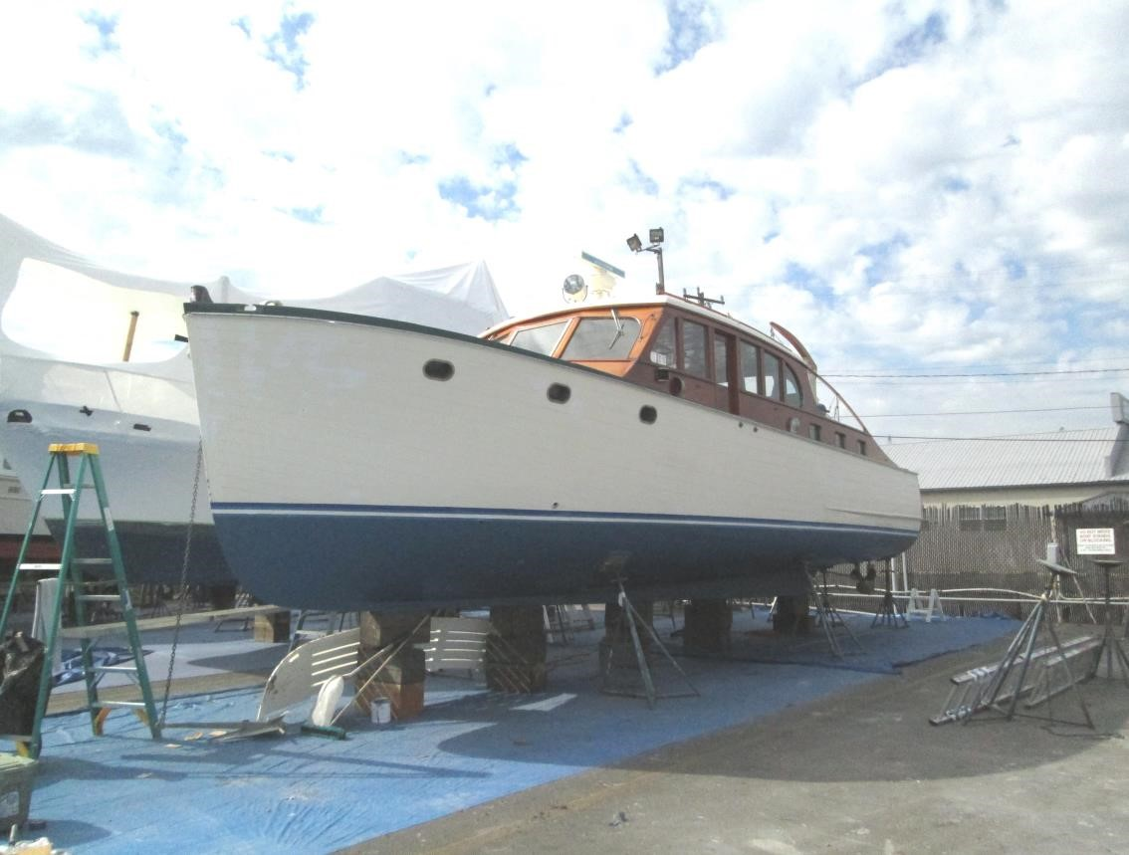

The Class Act is an Express Cruiser of wood construction designed by A. M. Deering, built by Herbert Ellis of Chicago Illinois in 1946. She has many WWII surplus parts, since the Chicago yard had produced PT Boats.
Class Act is a beautiful and functional cruiser she is a joy to operate. She cruises at 8 knots at 1800RPM burning 4 gal. per hr.. She is sea kindly and doesn’t leak, her bilge is totally dry at moorage and no perceptible water under way. Current covered moorage at Lockhaven marina is transferable.
Asking price $50,000
Hull Planking: Carvel planked construction, 1-1/8” Honduras mahogany.
Frames: White oak, 1-5/8” x 2”, steam bent, on approx. 9” centers. Keel: White oak, 5-1/2” sided.
Fastenings: Silicon bronze wood screws (#12 x 2”).
Transom: Honduras mahogany, 1 3/8” thick below the waterline and double planked
Engine(s): Diesel, two (2) Perkins model 4-236, 4 cyl. approx. 85 hp each (@2500 rpm) with Borg Warner model 71C Velvet Drive marine transmissions. Port gear ratio, 2.10:1. Stbd gear ratio, 1.91:1.
Cooling: Keel coolers (P&S), Walter 2 pass 1” dia. bronze tubes.

Deck: T&G with plywood and fiberglass overlay on the foredeck, side decks and aft deck. Canvas on coach roofs of pilothouse and aft trunk cabin.
Cabin: Varnished Honduras mahogany sides with large pilothouse windows and hinged doors (P&S).

Class Act’s maiden voyage was in Seattle, and has been in service in this area since then. The vessel is kept under covered moorage in the fresh water of the Seattle Ship Canal. She was extensively rebuilt and upgraded by the former owner, Mike Jordan, including the following.
Hull refastened with bronze screws 21014
Transom rebuilt
Deck and house coverings replaced
New electrical system & Link 1000 Battery monitoring system 2004

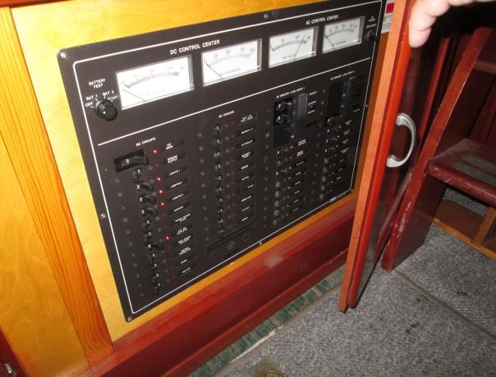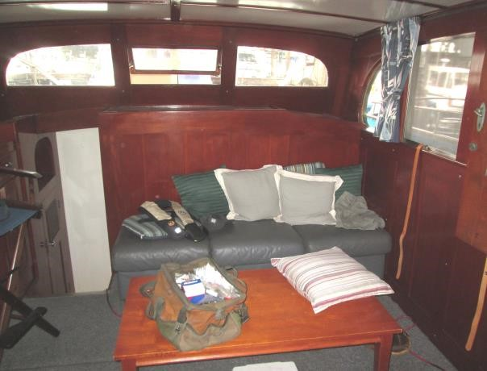

DC and AC control panels.

Looking aft in the pilot house.

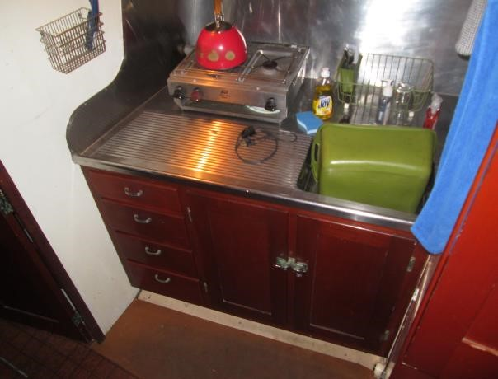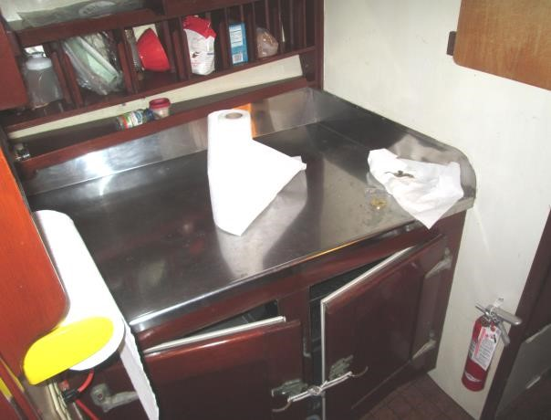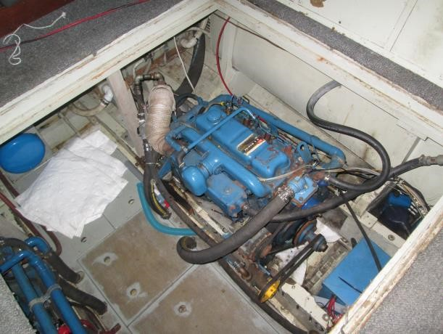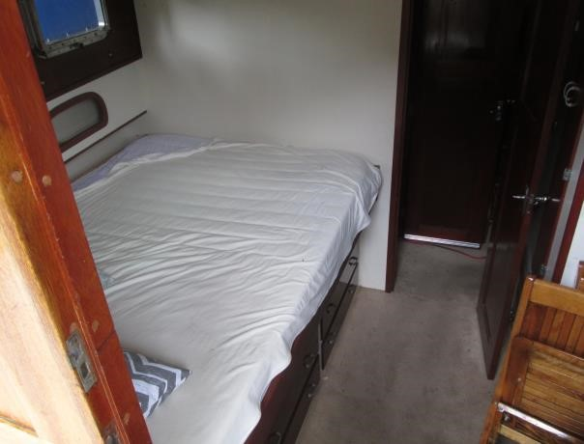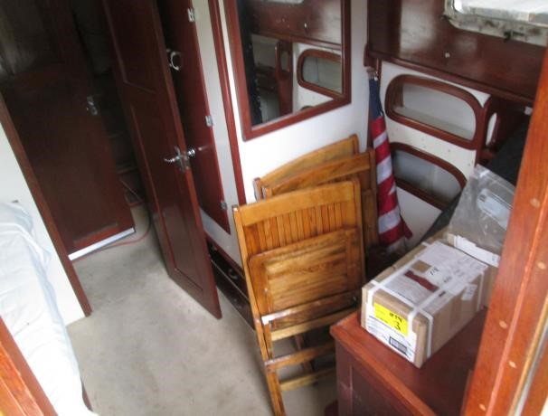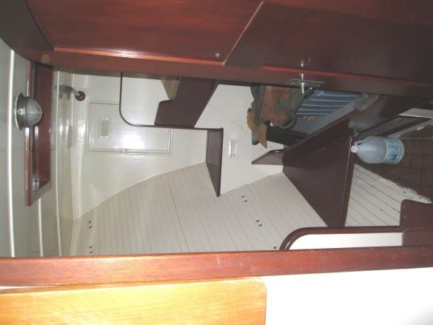

Looking down to stbd in
to

the galley.

Looking down to port in
to

the galley
.

Looking into the fwd stateroom. Looking down on the port engine. Stbd the same.

